**Loading The Data**

The dataset for this model is imported from the Keras module.

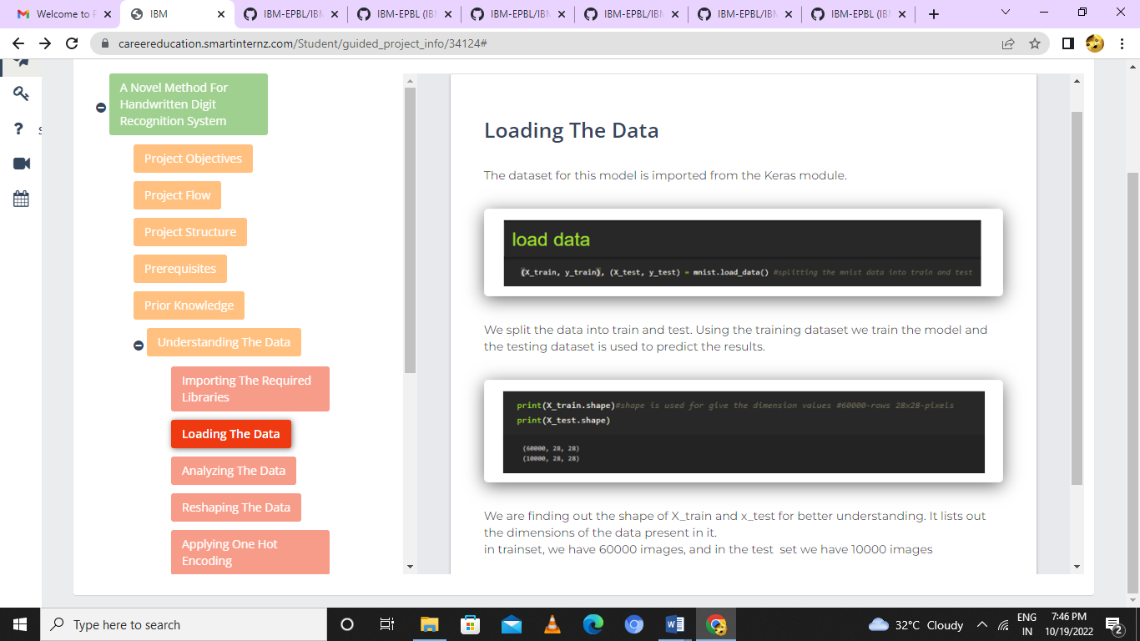

We split the data into train and test. Using the training dataset we train the model and the testing dataset is used to predict the results.



We are finding out the shape of X_train and x_test for better understanding. It lists out the dimensions of the data present in it.

in trainset, we have 60000 images, and in the test  set we have 10000 images